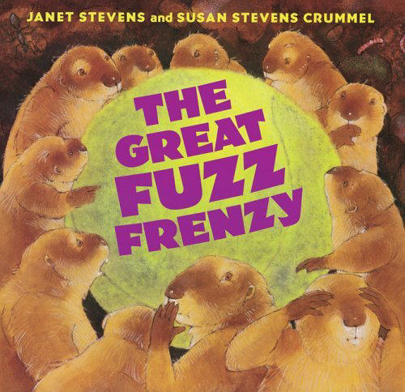

**The tennis ball fell down the hole.**

**The prairie dogs all froze.**

**But then they pulled that fuzz right off**

**And dressed in fuzzy clothes!**

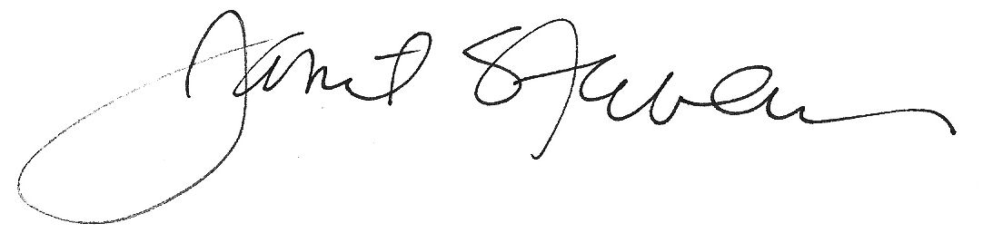

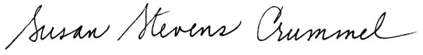

**Big Brown Rooster wanted to cook**

**the shortcake in great-granny’s wonderful book.**

**Iguana and Turtle and Pig join the fun.**

# **Ding! Do you think that the shortcake is done?**

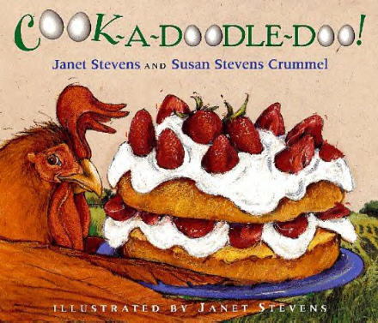

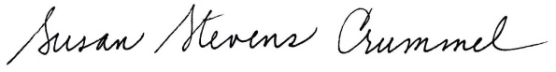

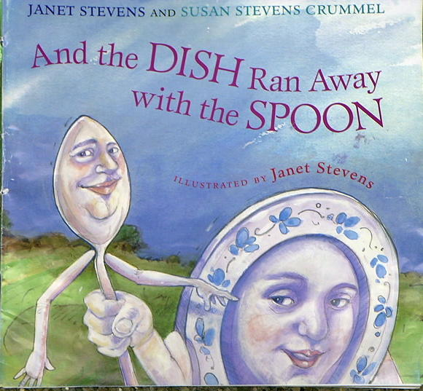

**Hey Diddle Diddle, the cat and the fiddle,**

**and you know the rest of the rhyme.**

## **Dog, Cat, and Cow go in search of the pair--**

**and have a hilarious time!**



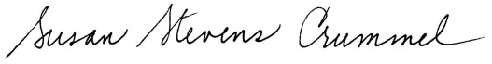

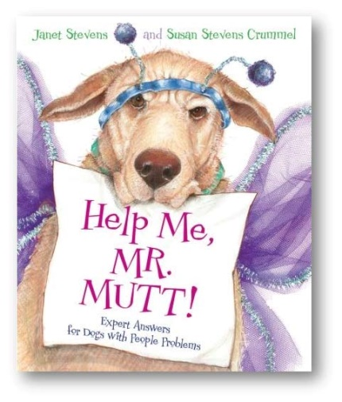

**Are you a dog with problems?**

**A Rover in a rut?**

**For all your dog dilemmas**

**Write to Mr. Mutt!**

